Securing IEEE 802.15.4 for IoT Applications: Analyzing PHY and MAC Layer Vulnerabilities
Mata, Maria Sarah Althea A.
1st author's affiliation
Torre De Manila, Taft Ave.,
Ermita, Manila
+63 9171649110
maria_sarah_mata@dlsu.edu.ph

Ranada, Arianne M.
2nd author's affiliation
126 Ipil St., Marikina Hts., Marikina City
+63 9982450128
arianne_ranada@dlsu.edu.ph

ABSTRACT
The IEEE 802.15.4 standard is foundational for low-power wireless networks, particularly in the Internet of Things (IoT) domain. While it offers low-cost and energy-efficient communication suitable for resource-constrained devices, its lightweight design introduces significant security vulnerabilities at the Physical (PHY) and Medium Access Control (MAC) layers. This paper analyzes these vulnerabilities, classifies them, and examines their implications for IoT and low-power networks. By highlighting the cross-layer cascading effects of these security gaps and leveraging comparative analysis, we aim to provide a comprehensive understanding of the challenges and lay the groundwork for effective mitigation strategies tailored to real-world applications.
Keywords:IEEE 802.15.4, IoT security, PHY layer, MAC layer, jamming attack, ACK spoofing, channel hopping, frame masking, low-power networks

INTRODUCTION
The IEEE 802.15.4 standard underpins a wide array of low-power wireless networks, facilitating applications in healthcare, industrial automation, smart homes, and environmental monitoring [1]. Its emphasis on low-cost and low-power communication makes it ideal for resource-constrained IoT devices. The standard’s specifications for the PHY and MAC layers have made it a popular choice for Wireless Sensor Networks (WSNs) and Low-Rate Wireless Personal Area Networks (LR-WPANs) [2].
However, the lightweight design of IEEE 802.15.4 introduces trade-offs, particularly in security. The shared wireless communication medium at the PHY layer and simplified protocols at the MAC layer create vulnerabilities that adversaries can exploit [3]. These weaknesses can disrupt operations, compromise data integrity, and breach privacy. Vulnerabilities such as jamming, acknowledgment manipulation, and replay attacks are of particular concern in critical applications, where delays or data loss can lead to severe consequences, such as in healthcare monitoring and industrial automation systems.
This paper seeks to address these challenges by analyzing vulnerabilities at the PHY and MAC layers of IEEE 802.15.4 networks. The researchers aim to classify these vulnerabilities, evaluate their implications for IoT and low-power networks, and provide a comparative analysis to identify cascading effects and mitigation strategies.

Review of Related Literature
- PHY Layer
The Physical (PHY) layer is the foundation of data transmission in IEEE 802.15.4 networks, enabling devices to communicate over a shared wireless medium. This reliance on shared communication channels makes the PHY layer inherently vulnerable to attacks such as jamming, message manipulation, and eavesdropping. Amin and Abdel-Hamid classify these vulnerabilities into two broad categories: availability attacks, such as jamming, and data integrity attacks, such as signal manipulation [2]. Jamming is one of the most disruptive threats, as it involves transmitting interference signals to degrade or completely block communication. Xu et al. identify various forms of jamming, including constant, deceptive, random, and reactive jamming, with the latter being particularly challenging to detect due to its selective activation when legitimate communication occurs [3].
Additionally, signal manipulation attacks, such as symbol flipping and overshadowing, can alter transmitted data, jeopardizing data integrity. Furthermore, Çamtepe and Yener explore steganography as a subtler attack vector, where adversaries embed covert messages in unused PHY frame fields to create hidden communication channels for data exfiltration or further attacks [7].
Zayani et al. (2012) further reinforce the significance of the PHY layer's integrity, noting that vulnerabilities like signal attenuation or interference not only degrade communication but also increase retransmissions at the MAC layer, exacerbating overall network inefficiency. This highlights the interplay between the two layers and the cascading effects that can arise when PHY-layer vulnerabilities are exploited [9].

- MAC Layer
The Medium Access Control (MAC) layer, which governs channel access and coordinates data exchange, is susceptible to a range of attacks that compromise reliability and resource allocation. Replay attacks, as noted by Wood and Stankovic, exploit the absence of packet freshness validation to retransmit previously captured legitimate packets, leading to unauthorized access, data duplication, and wasted energy [4]. Another significant MAC layer threat is acknowledgment (ACK) manipulation, which includes ACK spoofing and dropping. Law et al. highlight that such attacks undermine communication reliability, as spoofed ACKs prevent necessary retransmissions while dropped ACKs increase resource consumption due to repeated attempts [5].
Back-off manipulation, discussed by Chiang and Hu, targets the contention-based channel access mechanism of the MAC layer. Attackers exploit contention windows to monopolize communication channels, starving legitimate devices of resources and causing network congestion [6]. This manipulation disrupts network fairness and exacerbates collisions and delays in communication, particularly in time-sensitive IoT applications.
Sastry and Wagner (2004) emphasize that MAC-layer weaknesses, such as improper initialization vector (IV) management and insufficient integrity protection, can lead to cascading vulnerabilities that impact the PHY layer, enabling attacks like jamming and eavesdropping [10]. Similarly, Saleem et al. (2011) highlight that DoS attacks during the Contention Access Period (CAP) of the MAC layer can create vulnerabilities at the PHY layer, undermining the reliability of Wireless Body Area Networks (WBANs) [11].
- Synthesis of Findings
The vulnerabilities at the PHY and MAC layers are interconnected, often compounding the impact of attacks. For instance, a jamming attack at the PHY layer can trigger retransmissions at the MAC layer, resulting in congestion and energy depletion [3]. Likewise, improper MAC-layer contention management can increase PHY-layer vulnerability to interference or signal loss.
Zayani et al. (2012) and Saleem et al. (2011) underscore these interdependencies, highlighting how vulnerabilities propagate across layers and degrade the overall performance and security of IEEE 802.15.4 networks [9][11]. Amin and Abdel-Hamid emphasize the cascading effects of these cross-layer vulnerabilities, which highlight the importance of holistic security frameworks that address both PHY and MAC vulnerabilities simultaneously [2]. Without addressing these interdependencies, security measures targeting a single layer may prove insufficient in safeguarding IEEE 802.15.4 networks.

Methodology
The research design focuses on identifying, classifying, and analyzing vulnerabilities at the PHY and MAC layers of IEEE 802.15.4 networks. By synthesizing data from both experimental and theoretical studies, the methodology ensures a balanced understanding of the practical implications and theoretical underpinnings of these vulnerabilities.
- Discussion and Findings
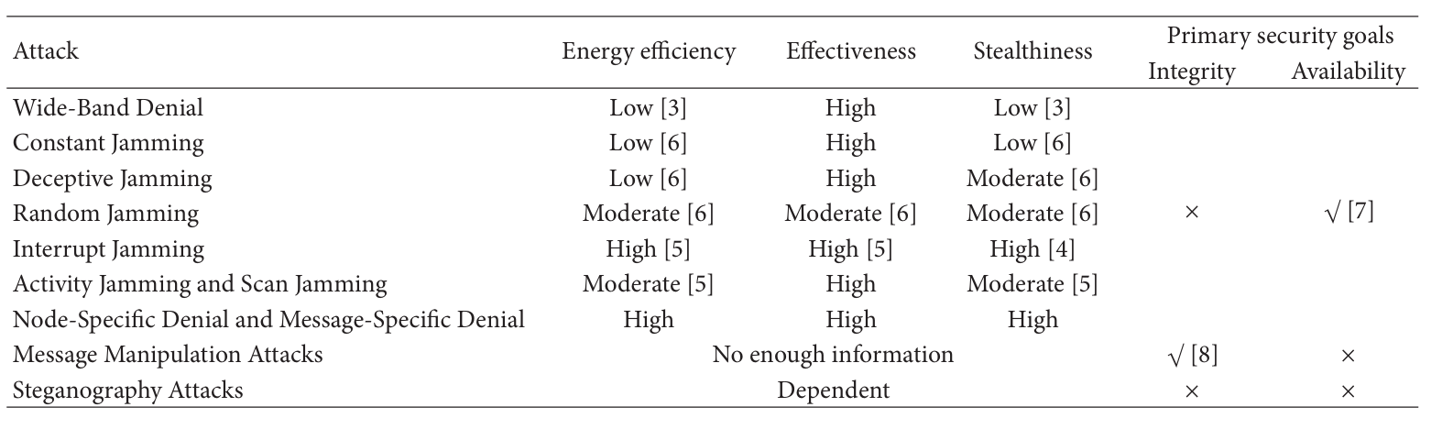
Table 1: Comparative analysis of IEEE 802.15.4 PHY layer attacks
The findings from the literature review and comparative analysis reveal critical vulnerabilities at both the PHY and MAC layers, emphasizing their cascading effects on network performance. At the PHY layer, jamming attacks emerge as the most disruptive threat, primarily affecting network availability. Table 1 highlights that wide-band and constant jamming are highly effective but energy-intensive, making them easier to detect. In contrast, reactive jamming, which selectively disrupts communication, poses a greater challenge due to its stealth and efficiency, particularly in resource-constrained IoT applications [2], [3].
Additionally, steganography and message manipulation attacks compromise data integrity by embedding covert information or altering transmitted packets, leading to long-term breaches in critical systems such as healthcare and industrial automation [6]. These types of attacks can undermine the reliability of medical data in healthcare systems, where real-time data accuracy is critical for patient safety, or compromise the performance of automated machinery in industrial settings, where delays or errors can lead to costly equipment failures.
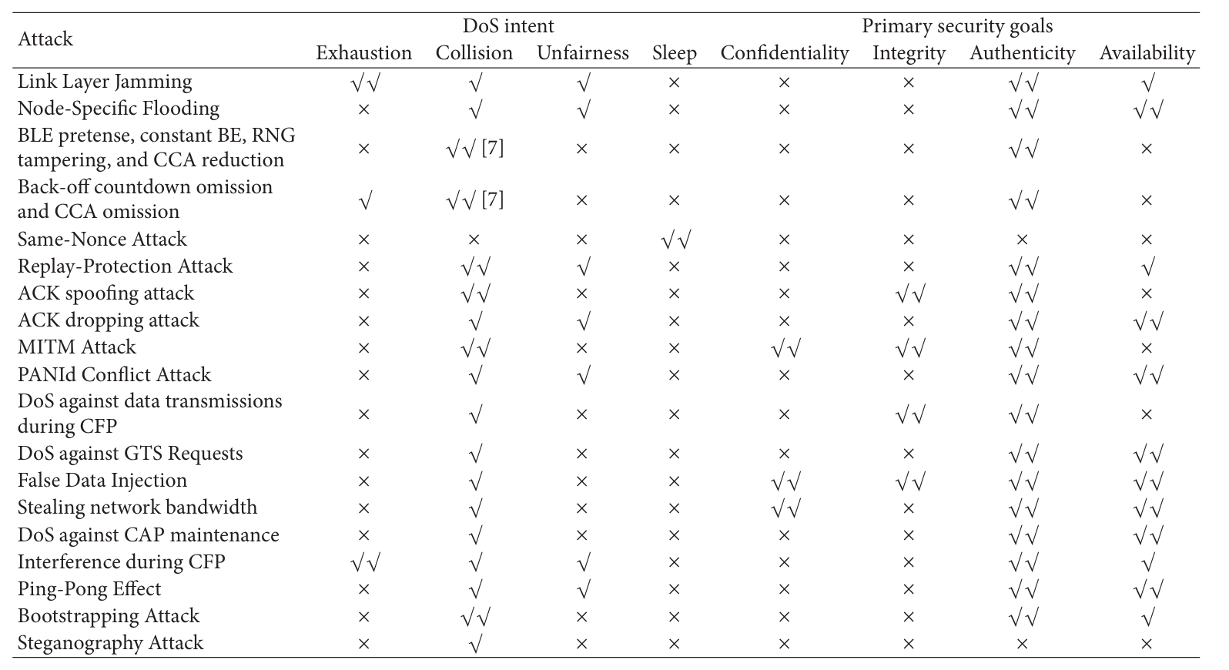
Table 2: Comparative analysis of IEEE 802.15.4 MAC layer attacks
At the MAC layer, vulnerabilities such as acknowledgment (ACK) manipulation and replay attacks degrade network reliability and increase energy consumption. ACK spoofing misleads devices with false acknowledgments, while ACK dropping forces excessive retransmissions, consuming limited resources. Replay attacks exploit the lack of freshness validation in IEEE 802.15.4, leading to unauthorized and redundant transmissions that increase latency and energy usage. As shown in Table 2, these vulnerabilities are particularly detrimental in time-sensitive applications, such as industrial automation, where reliable communication and minimal delay are crucial [4], [5]. For instance, in industrial settings, ACK spoofing could prevent critical control signals from being acknowledged, which might result in unscheduled equipment downtime or delayed responses from automated machinery.
Cross-layer dependencies amplify these vulnerabilities, with attacks at one layer triggering failures in another. For example, jamming at the PHY layer causes packet loss and triggers retransmissions at the MAC layer, leading to congestion and energy depletion. Similarly, back-off manipulation at the MAC layer exacerbates PHY-layer vulnerabilities by increasing channel contention, further reducing availability and fairness. These cascading effects underscore the importance of designing holistic security frameworks that address interdependencies across both layers [2].
- Implications for IoT and Low-Power Networks
The identified vulnerabilities have profound implications for IoT and low-power networks, especially in domains requiring reliable, low-latency, and energy-efficient communication.
  - Healthcare Applications: In healthcare systems that rely on real-time data transmission, vulnerabilities such as jamming and acknowledgment (ACK) manipulation can be particularly detrimental. For instance, a jamming attack could delay critical alerts from wearable health monitoring devices, potentially endangering patient safety. Similarly, ACK manipulation might prevent the successful delivery of vital health data, leading to incomplete records or incorrect decisions. These disruptions underscore the necessity for robust security measures to maintain data integrity and timely communication in healthcare IoT devices.
  - Industrial Automation: IoT networks in industrial environments depend on precise, time-sensitive communication for machine-to-machine interactions. Replay attacks could reissue outdated or malicious commands, causing machinery to operate unsafely or inefficiently. Back-off manipulation exploits the MAC layer's contention mechanisms, monopolizing the communication channel and delaying critical processes. Such disruptions can lead to production delays, financial losses, and safety risks, highlighting the importance of securing communication protocols in industrial IoT applications.
  - Smart Homes and Consumer IoT: In smart home environments, privacy and data integrity are major concerns. Vulnerabilities like steganography and replay attacks enable attackers to manipulate or intercept data, compromising user trust in automated systems. For example, an attacker could exploit steganography to issue unauthorized commands to smart devices such as locks or thermostats, posing risks to user safety. These threats emphasize the need for effective security measures to protect consumer IoT devices from unauthorized access and control.

AI-Generated Findings
This section presents ChatGPT’s insights on the vulnerabilities present at the PHY and MAC layers in IEEE 802.15.4 networks, their impacts on network performance and security, the interdependencies between these layers, and a comparative analysis.

- Vulnerabilities in the PHY and MAC Layer
The IEEE 802.15.4 standard, widely utilized in IoT networks, has several critical vulnerabilities at both the Physical (PHY) and Medium Access Control (MAC) layers. At the PHY layer, vulnerabilities such as jamming attacks, eavesdropping, replay attacks, and spoofing present significant security risks. Jamming attacks disrupt communication by flooding the spectrum with interference, making the network unusable. Eavesdropping exposes sensitive data to unauthorized access, especially in the absence of encryption at higher layers. Replay attacks, where previously captured signals are retransmitted, create confusion in the network, while spoofing allows malicious devices to impersonate legitimate ones, further disrupting communication flows.
On the MAC layer, vulnerabilities such as energy exhaustion attacks, Denial of Service (DoS) attacks, beacon frame manipulation, ACK spoofing, and poor key management undermine network reliability and security. Energy exhaustion attacks force devices to consume excessive energy by triggering frequent retransmissions, while DoS attacks exploit contention-based access mechanisms, monopolizing the communication channel and preventing legitimate devices from accessing it. Beacon frame attacks can tamper with or flood beacon signals, causing synchronization failures, and ACK spoofing misleads devices by sending false acknowledgment messages, creating a false sense of successful communication. Finally, weaknesses in key management expose networks to various attacks, especially if shared encryption keys are not securely managed.
- Comparative Analysis of PHY and MAC Layer Vulnerabilities
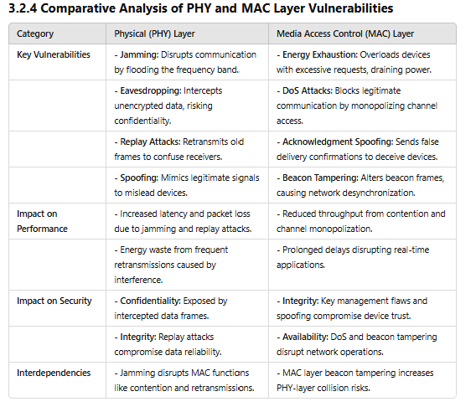
This table provides a comparative analysis of the key vulnerabilities in the PHY and MAC layers of IEEE 802.15.4 networks, highlighting the primary security threats at each layer. It demonstrates how these vulnerabilities impact network performance and security, emphasizing the interdependencies between the layers, where weaknesses in one can exacerbate issues in the other, compromising overall network efficiency.
- Impact of Vulnerabilities on Performance and Security
The vulnerabilities at the PHY and MAC layers significantly degrade both performance and security in IEEE 802.15.4 networks. In terms of performance, attacks like jamming increase latency, as devices are forced to retransmit data after packets are lost. Contention-based attacks, including DoS and back-off manipulation, monopolize the communication channel, resulting in prolonged back-off times and reduced throughput, which severely affect applications requiring real-time data transmission. Energy exhaustion attacks diminish a device’s operational lifetime by depleting its power reserves, while network instability, due to beacon frame manipulation, leads to synchronization failures and disconnected devices. From a security perspective, eavesdropping at the PHY layer compromises data confidentiality, while replay and spoofing attacks at the MAC layer undermine data integrity by allowing unauthorized data transmission or altering messages. DoS attacks can disrupt operations by disabling network communication, and poor key management increases the risk of unauthorized access. These vulnerabilities weaken trust in IoT networks, particularly in critical applications such as healthcare, industrial automation, and smart cities.
- Relationship between PHY and MAC Layers
The vulnerabilities at the PHY and MAC layers are closely intertwined, and weaknesses in one layer often amplify vulnerabilities in the other. For example, jamming attacks at the PHY layer lead to packet loss, which triggers retransmissions at the MAC layer, causing network congestion and energy depletion. Similarly, eavesdropping on the PHY layer can compromise key management at the MAC layer, enabling further attacks such as spoofing and replay. At the MAC layer, vulnerabilities such as back-off manipulation and DoS attacks exacerbate the impact of PHY-layer issues like jamming or energy exhaustion, creating a feedback loop of vulnerabilities. These cascading effects highlight the need for a holistic security approach, where countermeasures are designed to address vulnerabilities across both layers, rather than isolating them. For instance, while the PHY layer may implement countermeasures like frequency hopping to mitigate jamming, these defenses may become ineffective if the MAC layer fails to synchronize with these changes. Addressing these interdependencies is critical to ensuring the security and stability of IEEE 802.15.4 networks.
- Conclusion
After comparing the findings from studies against the AI-generated insights, it can be concluded that ChatGPT is reliable in some aspects, such as identifying key vulnerabilities in IEEE 802.15.4 networks and proposing theoretical metrics like packet delivery ratio, energy consumption, and latency to measure their impact. ChatGPT serves as a strong starting point for outlining challenges and offering general solutions based on prior research. However, it is less reliable in capturing nuanced cross-layer dependencies and the cascading effects of vulnerabilities, such as how jamming at the PHY layer exacerbates MAC layer retransmissions and energy depletion.
While the AI-generated findings align with the studies considered in this paper, they lack the depth of human analysis, particularly in contextualizing these vulnerabilities in real-world scenarios. The studies reviewed provide stronger empirical support through simulation and experimentation, offering a more detailed understanding of the interdependencies between the PHY and MAC layers and their implications for IoT and low-power networks.
Overall, the strategies discussed in this paper are grounded in evidence and provide actionable insights for addressing security vulnerabilities in IEEE 802.15.4 networks. Future research should focus on integrating AI tools with human analysis to improve the accuracy and applicability of findings.

REFERENCES
- IEEE Standard for Low-Rate Wireless Networks, IEEE Std 802.15.4-2020 (Revision of IEEE Std 802.15.4-2015), pp. 1–800, July 2020.
- Y. M. Amin and A. T. Abdel-Hamid, "A Comprehensive Taxonomy and Analysis of IEEE 802.15.4 Attacks," Journal of Electrical and Computer Engineering, vol. 2016, Article ID 7165952, 12 pages, 2016.
- W. Xu, W. Trappe, Y. Zhang, and T. Wood, "The feasibility of launching and detecting jamming attacks in wireless networks," in Proc. 6th ACM Int. Symp. Mobile Ad Hoc Networking and Computing, 2005, pp. 46–57.
- A. D. Wood and J. A. Stankovic, "Denial of service in sensor networks," Computer, vol. 35, no. 10, pp. 54–62, Oct. 2002.
- Y. W. Law, L. Van Hoesel, J. Doumen, P. Hartel, and P. Havinga, "Energy-efficient link-layer jamming attacks against wireless sensor network MAC protocols," in Proc. 3rd ACM Workshop on Security of Ad Hoc and Sensor Networks, 2005, pp. 76–88.
- J. T. Chiang and Y.-C. Hu, "Cross-layer jamming detection and mitigation in wireless broadcast networks," IEEE/ACM Transactions on Networking, vol. 19, no. 1, pp. 286–298, 2011.
- S. Çamtepe and B. Yener, "Key distribution mechanisms for wireless sensor networks: a survey," IEEE Wireless Communications, vol. 12, no. 2, pp. 16–28, Apr. 2005. [Online]. Available: https://doi.org/10.1109/MWC.2005.1421929
- Z. Zayani, A. Belghith, and A. Bouabdallah, "A Joint Model for IEEE 802.15.4 Physical and Medium Access Control Layers," in Proc. IEEE Int. Symp. Personal, Indoor, and Mobile Radio Communications (PIMRC), 2012, pp. 2212–2216. [Online]. Available: https://doi.org/10.1109/PIMRC.2012.6362786
- N. Sastry and D. Wagner, "Security Considerations for IEEE 802.15.4 Networks," in Proc. ACM Workshop on Wireless Security (WiSe), 2004, pp. 32–42. [Online]. Available: https://doi.org/10.1145/1023646.1023651
- Y. Saleem, N. Crespi, and A. Derhab, “Internet of Things for Healthcare: A Comprehensive Survey on Security, Privacy, and Access Control,” Electronics, vol. 13, no. 12, p. 2309, June 2022. [Online]. Available: https://www.mdpi.com/2079-9292/13/12/2309
- K. Sharma and A. K. Ray, “Secure Machine-to-Machine Communication Protocols in Industrial IoT Networks: A Review,” Sensors, vol. 21, no. 11, p. 3654, May 2021. [Online]. Available: https://www.mdpi.com/1424-8220/21/11/3654
- S. Sisodia and J. Mishra, “Privacy and Security Framework for Smart Home IoT Devices,” University of Oregon Technical Reports, Jan. 2020. [Online]. Available: https://www.cs.uoregon.edu/Reports/AREA-202001-Sisodia.pdf

